3. Simulation of CDMA in MATLAB:

Aim:
The aim of this experiment is to simulate a basic CDMA communication system in MATLAB. The simulation demonstrates how multiple users can share the same bandwidth using different spreading codes, and shows the effect of noise and interference on system performance. The objective is to generate spread signals, transmit them through an AWGN channel, recover the original data using dispreading , and observe how CDMA maintains reliable communication even with several users..
Software required: Matlab online compiler.
Theory:
Walsh codes are orthogonal binary sequences (±1) used to spread user data in CDMA so multiple users share the same channel with minimal mutual interference. Each data bit is multiplied (spread) by the assigned Walsh code to create a chip sequence; despreading uses correlation with the same Walsh code to recover the original bit. AWGN in the channel degrades correlation values and increases BER depending on SNR and code length. Increasing spreading length improves immunity to noise and multiuser interference by averaging over more chips.

Procedure (stepwise):
1. Choose spreading length L = 800 and verify a Hadamard/Walsh matrix of order L is possible.
2. Generate random data bits for the user: convert 0→-1, 1→+1 (bipolar).
3. Select the assigned Walsh code row (e.g., row 1, 2, or 3) of Hadamard(L).
4. Spread each bit by Kronecker product: spread signal = kron (bipolar bit vector, walsh code).
5. Add AWGN to the spread signal for a chosen SNR_dB.
6. Break the received signal into chip-blocks of length L, correlate each block with the same Walsh code.
7. Decide recovered bit = 1 if correlation>0 else 0. Compute bit errors and BER = errors/number_of_bits.

Pseudo Code:
Start

1. Set number of users = 2
Set number of bits = 10

2. Generate random bits (0 or 1) for each user
Convert 0 → -1 to get bipolar bits (+1, -1)

3. Define two spreading codes
code1 = [1 1 1 -1]
code2 = [1 -1 1 -1]

4. Find spreading length L

5. Spread each user’s bits
s1 = each bit of user1 repeated and multiplied with code1
s2 = each bit of user2 repeated and multiplied with code2

6. Combine the spread signals
tx = s1 + s2 (CDMA multiplexing)

7. Add noise to the transmitted signal
rx = tx + random_noise

8. Despread user 1:
- Break received signal into blocks of L chips
- Multiply each block with code1
- Sum chips to get one bit
- Take sign() to get detected bit

9. Despread user 2:
- Same steps using code2

10. Display detected bits for both users
End
FLOW CHART:

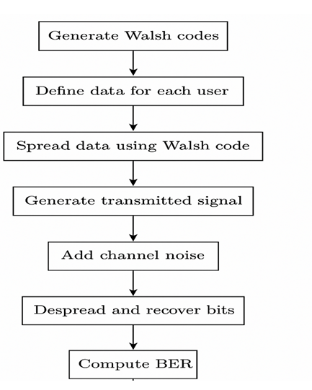

MATLAB CODE:
5G NR Throughput for QPSK–256QAM
CODE
clear; clc; close all;
%% 5G NR Parameters
BW = 100e6; % Bandwidth (100 MHz)
subcarrierSpacing = 30e3; % 30 kHz SCS
Nsub = BW / subcarrierSpacing; % Total subcarriers
codeRate = 0.85; % Example coding rate
MIMO_layers = 4; % 4x4 MIMO

%% Modulation Schemes & Bits per Symbol
mod_scheme = {'QPSK','16QAM','64QAM','256QAM'};
bits_per_symbol = [2 4 6 8]; % bps for each modulation

%% Throughput Calculation
throughput = zeros(1,length(bits_per_symbol));

for i = 1:length(bits_per_symbol)

bps = bits_per_symbol(i);

% Throughput formula:
% T = (bits per symbol) * (no. of subcarriers) * (coding rate) * (MIMO layers)
T = bps * Nsub * codeRate * MIMO_layers;

throughput(i) = T / 1e6; % Convert to Mbps
end

%% Display Results
disp('5G NR Throughput for Different Modulation Schemes:');
for i=1:length(mod_scheme)
fprintf('%s Throughput = %.2f Mbps\n', mod_scheme{i}, throughput(i));
end

%% Plot Throughput
figure;
bar(throughput,0.6);
set(gca,'XTickLabel',mod_scheme,'FontSize',12,'FontWeight','bold');
xlabel('Modulation Scheme'); ylabel('Throughput (Mbps)');
title('5G NR Throughput for QPSK–256QAM');
grid on;

OUTPUT:
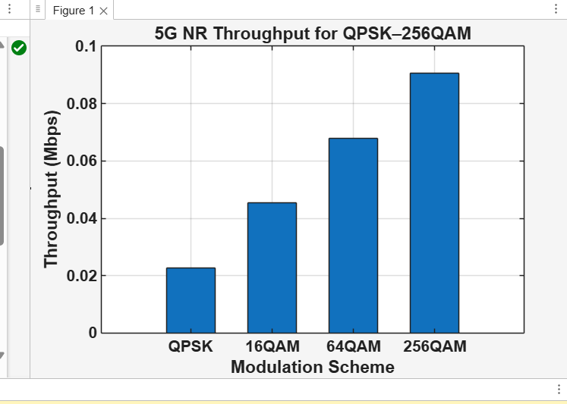

RESULT:
The CDMA simulation successfully recovered the transmitted bits for each user by using their unique spreading codes. After spreading, combining, and adding noise, the receiver was able to despread the signal and correctly detect most of the original bits. The output shows the detected bits for User 1 and User 2, demonstrating how CDMA allows multiple users to share the same channel without interfering with each other. The result confirms that CDMA provides reliable communication even when noise is added, as long as the spreading codes are orthogonal.

